**D Force 1**
**User Manual**

1. Product Introduction

1.1 Product Overview
- Brief Description: Motion System with software parameter tuning support (Circuit Manager)

1.2 Specifications

**D Force 1 Specifications**
Product Name | D Force 1
Product Type | Motion System
Power Unit | Low-inertia integrated lead screw servo drive motor
Material | Aerospace-grade aluminum alloy
Dimensions (L × W × H) | 139.7*95*257 mm
Single Axis Power | 3.55 Kg
Single Axis Power | 200 W
Single Axis Lifting Force | 180 Kg
Input Power Range | 110V-220V
Maximum Stroke | 50mm
Maximum Speed | 150mm/s
Frequency Rang | 0-100Hz
Operating Temperature Range | 0-40℃
Telemetry Data | Supported
Lighting Control (bindable with telemetry) | Supported
Optional Accessories | None

1.3 Package Contents
- D Force 1 unit
- Power supply
- Connection cables
- LINK controller
- Screw installation kit
- Bottom bowl mount (bowl tray)

1.4 Environmental Declaration & Certification Information

2. Usage Instructions

Thank you for purchasing the **D Force 1**.

Please read all accompanying documentation carefully before installing the product.

- For detailed firmware upgrade information, please visit: **www.circuitone.com**

- Game adaptation files are specially developed by Circuit One for D Force 1 compatible devices. To protect your rights, please download all files only from official Circuit One channels.

- Visit **www.circuitone.com** for product tutorials and usage tips.

- Check the official website **www.circuitone.com** for the list of supported games. Using the product with unsupported games may cause some functions to be unavailable.

2.1 Installation Guide

- Secure the D Force 1 to the cockpit using **M8×20** screws with nuts.

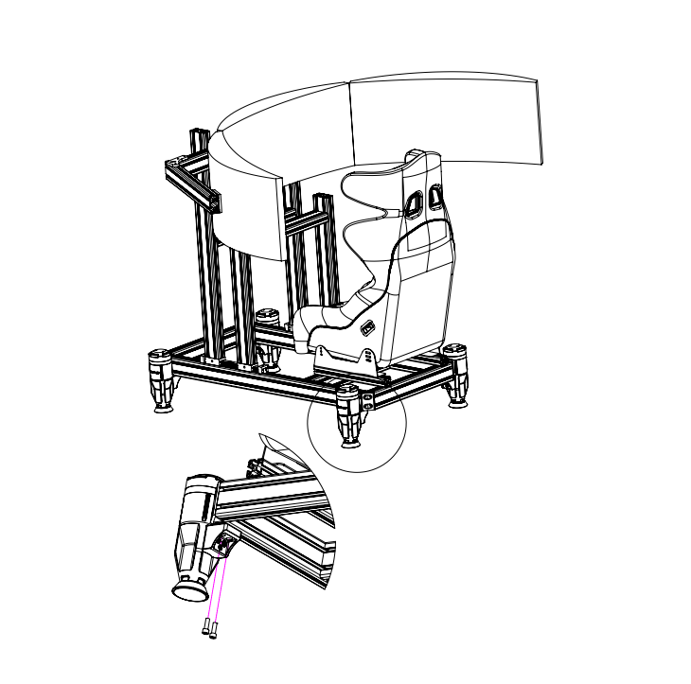

- Secure the LINK controller box to the cockpit using **M4×14** screws with nuts.
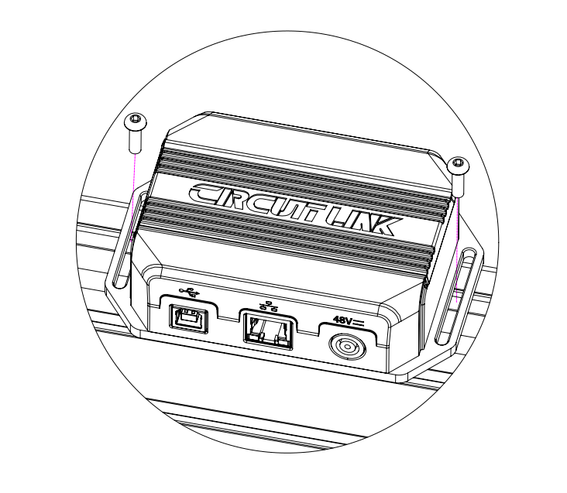

- Connect the D Force 1 to the LINK controller using the provided connection cable.
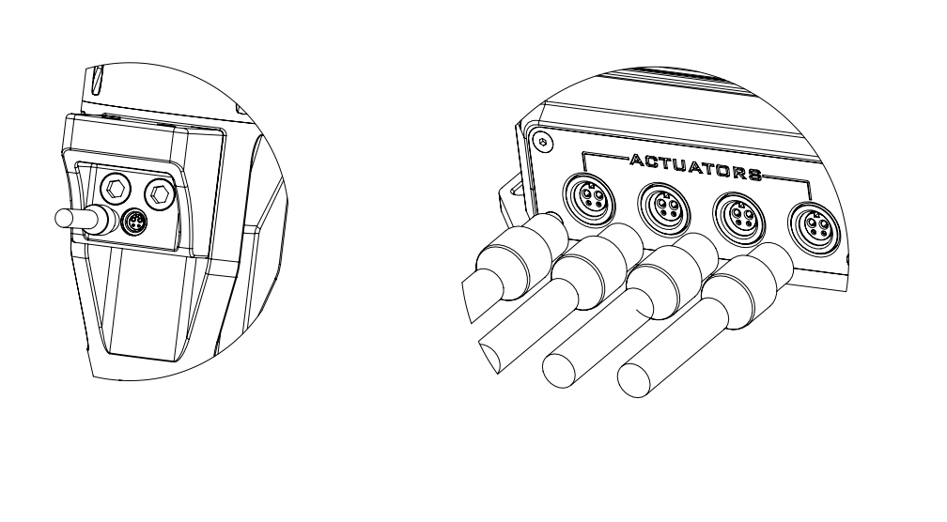

4. Connect the power supply and USB cable.

2.2 Product Dimensions
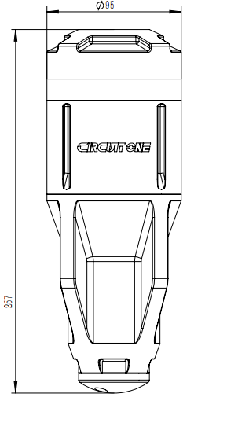

3. Software Operation Guide
3.1 Circuit Manager Software Overview
Circuit Manager is the dedicated device management software for Circuit One racing simulator products.
Core functions include: device management, function configuration, performance tuning, instrument configuration, firmware updates, and one-click game launch.

For first-time use, download the **Circuit Manager** configuration software for D Force 1.

3.2 Software Download and Installation
3.2.1 Downloading the Software**
1. Open the Circuit One official website (**www.circuitone.com**).
2. Go to **Download Center** → Select **Circuit Manager**.
3. Download the latest version and save the installation package.

3.2.2 Installation Steps**
1. Double-click the downloaded .exe file.
2. Follow the prompts to select the installation path (default is recommended).
3. Complete the installation.

3.2.3 First Launch**
1. Double-click the **Circuit Manager** icon on your desktop.
2. The software will automatically detect the device and install required drivers.
3. If a firmware update prompt appears, follow the on-screen instructions to complete the update.

3.3 Main Interface Introduction
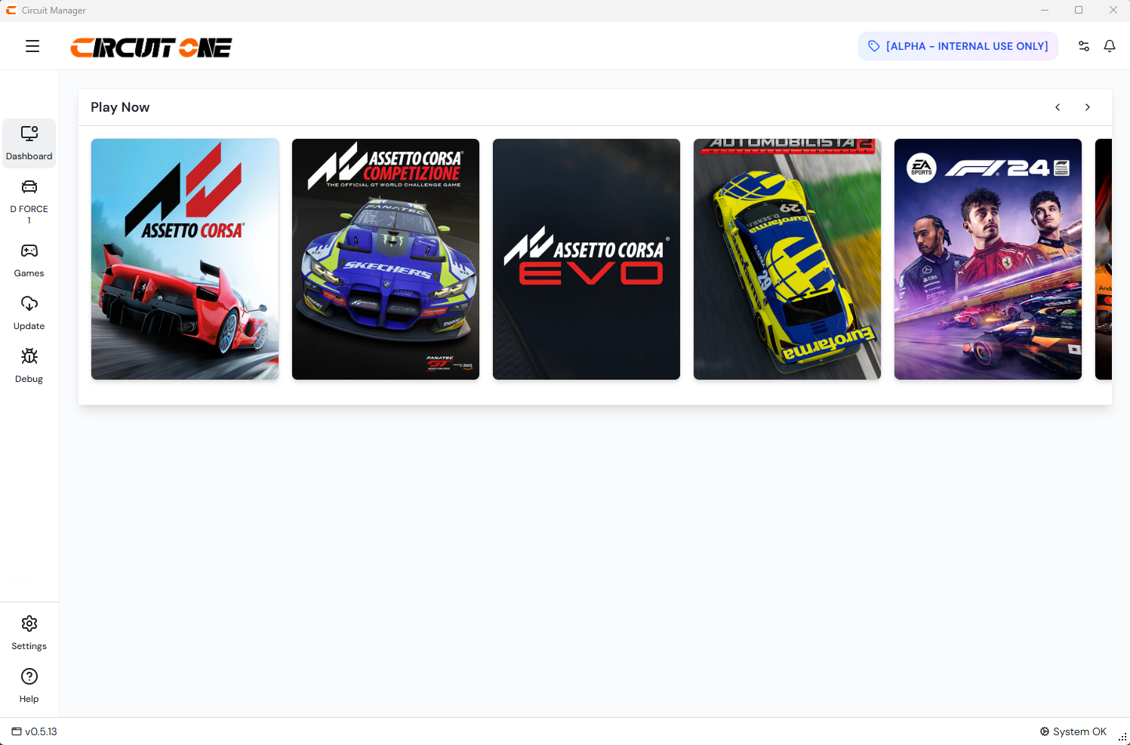

1. **Device View Entry**
Location: “D FORCE 1 (Device)” icon in the function bar.
Function: Click to enter device management page to view and manage connected devices.

2. **Game Dashboard** (Left side)
- Game list
- One-click game launch
Function: Quickly start games using bound presets.

3. **Game Adaptation Area** (Left side)
- List of adapted games
- Custom parameters for adapted games
Function: View supported games and select preferred presets.

4. **Update Area** (Left side)
- Automatic software & firmware version check
- Manual firmware import
Function: Keep your device up to date.

5. **Preset Area** (Top horizontal bar)
- Current preset name (e.g., V8 GT3)
- Preset tags (hover to preview associated games)
- Buttons: Undo, Redo, Save, Save As…
- Switch between official and user presets
Function: Easy management and switching of different setups.

3.4 Step-by-Step Operations
Step 1: Quick Launch Common Games
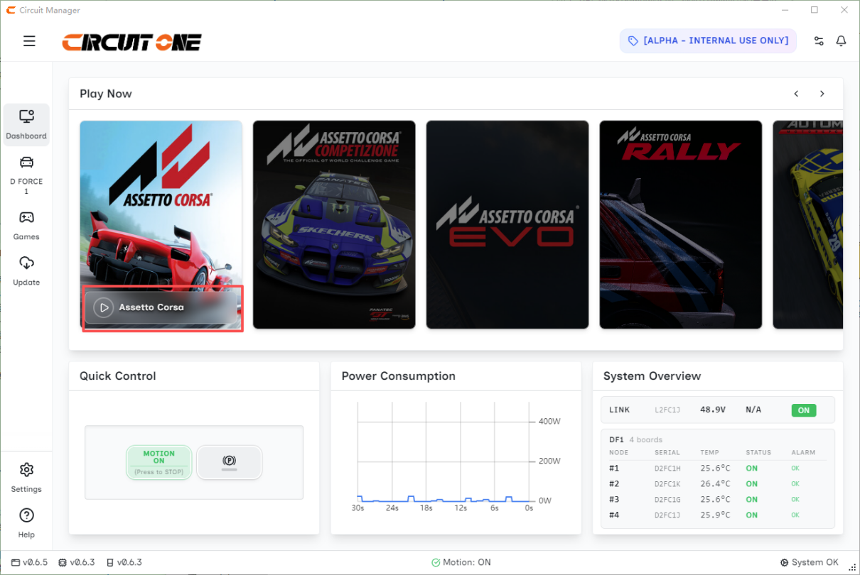

Step 2: Start the Device
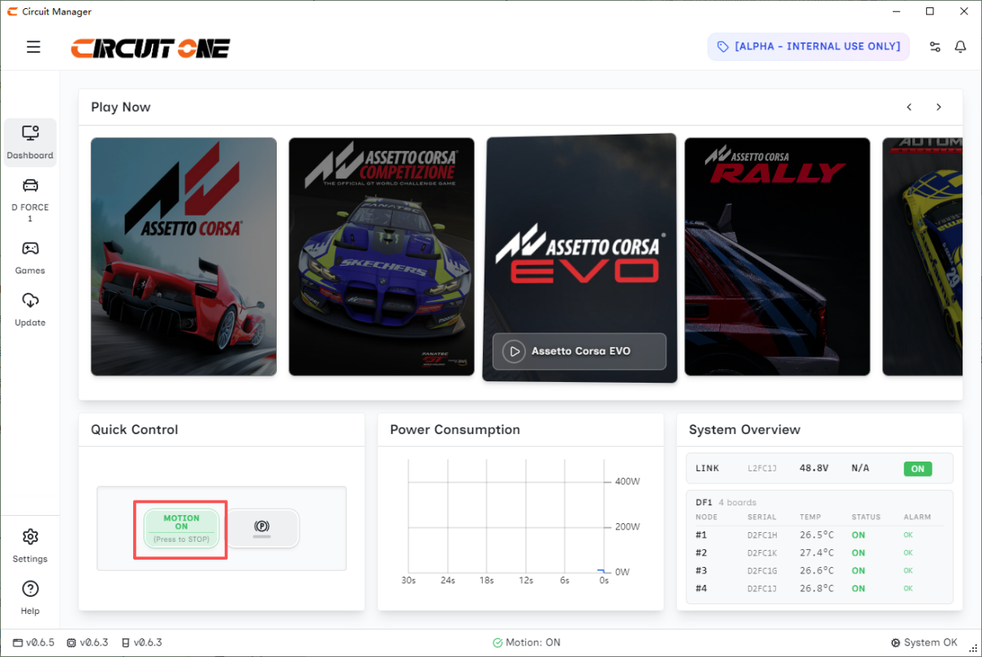

Step 3: Device Enters Standby Mode
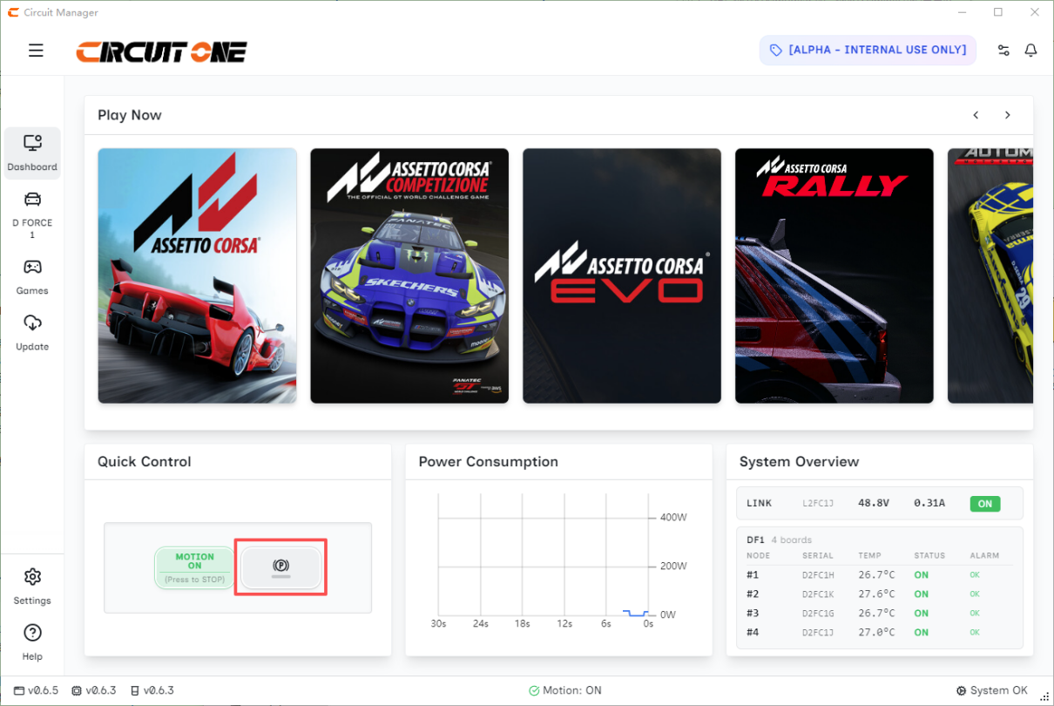

Step 4: Real-Time Power Consumption Display
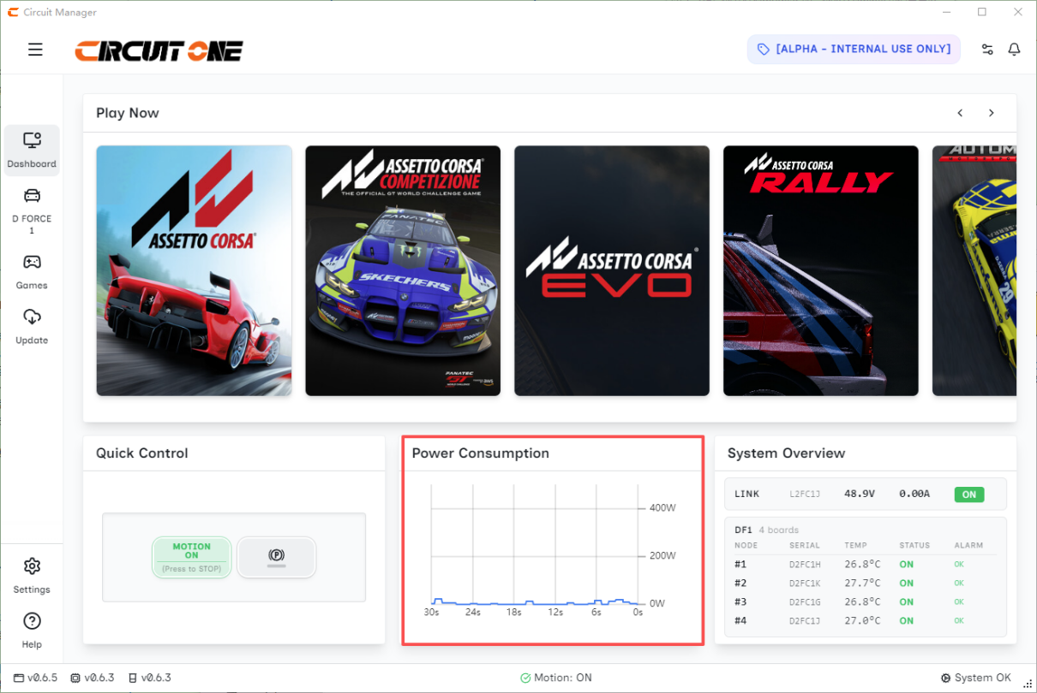

Step 5: Real-Time Device Status Display
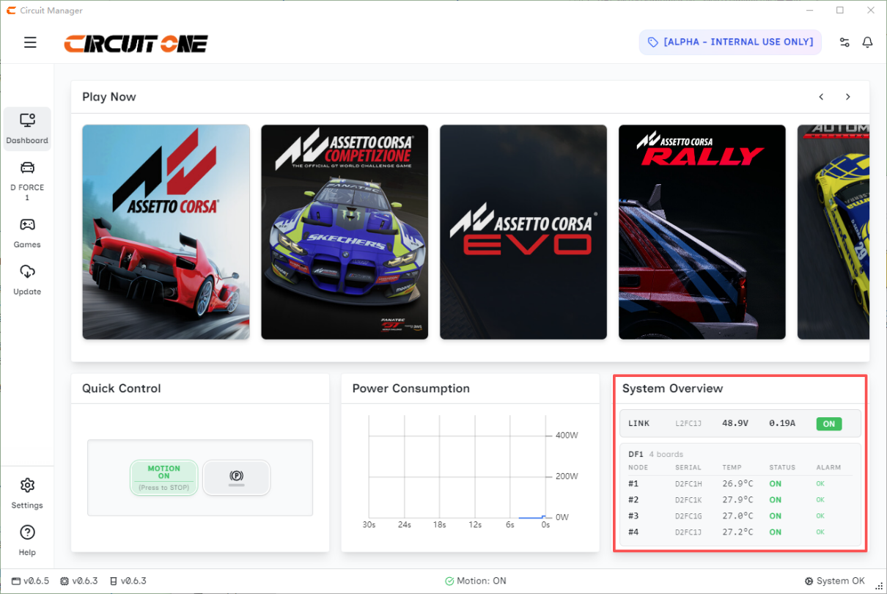

Step 6: Parameter Settings
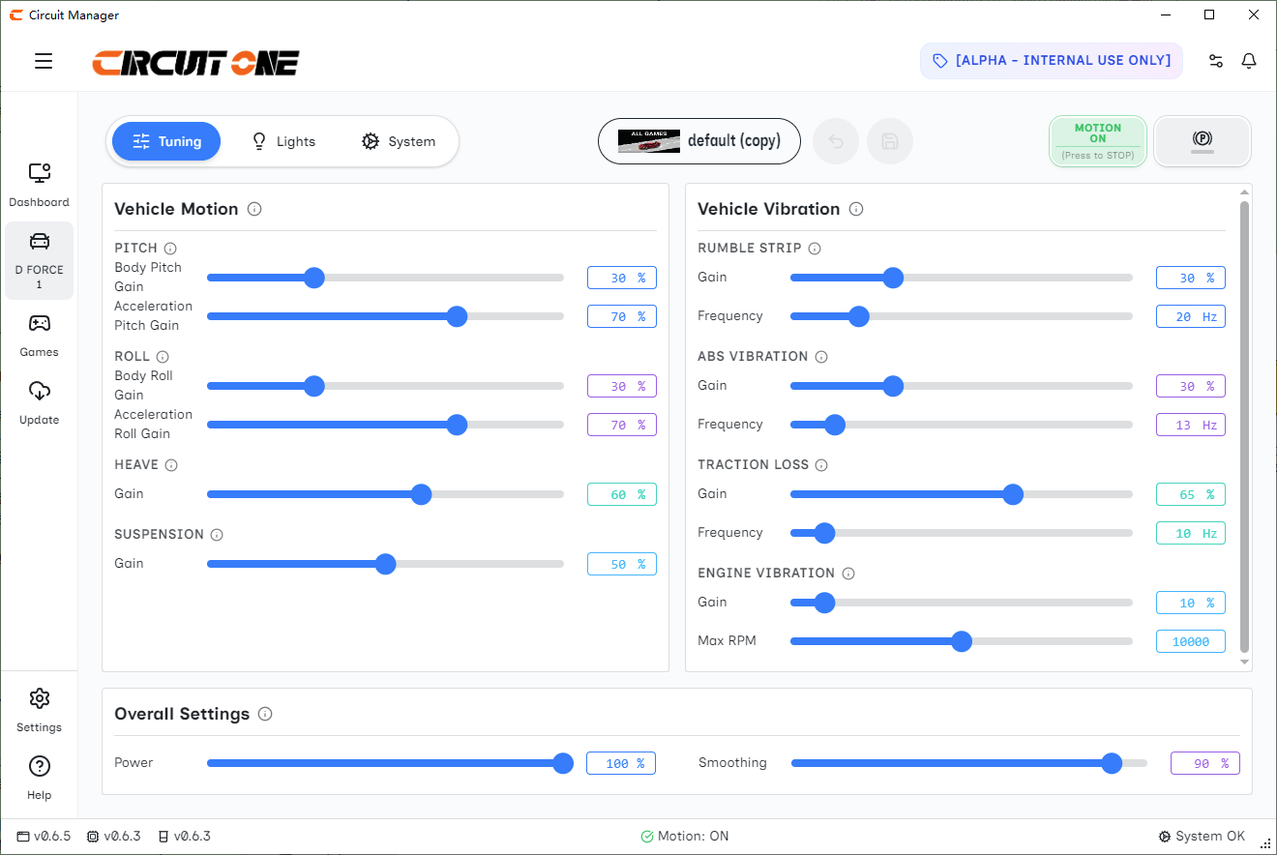

Step 7: Save Parameter Settings
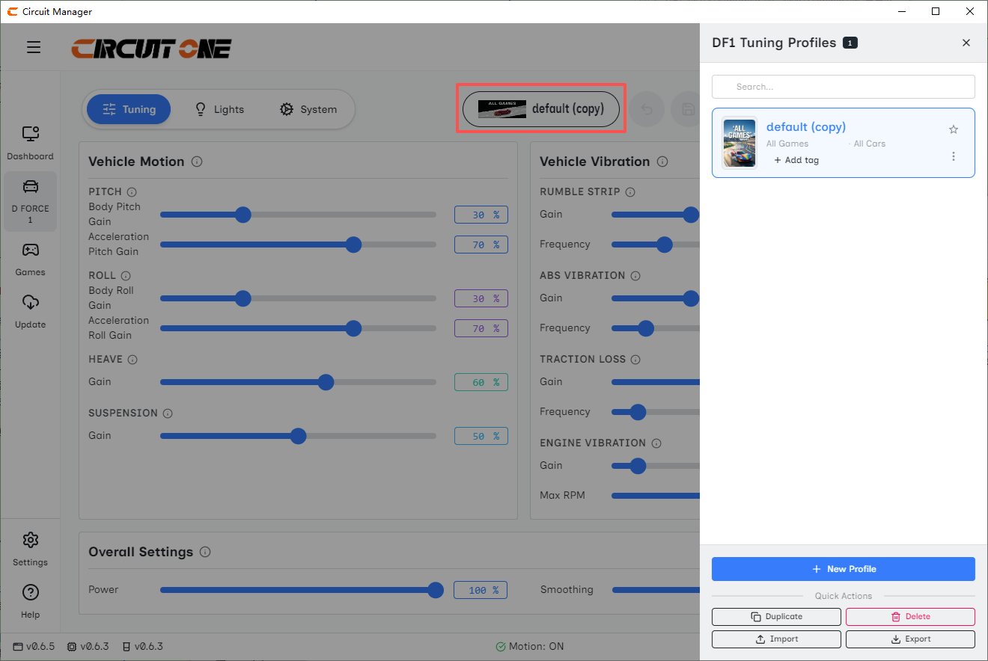

Step 8: Lighting Effects Settings
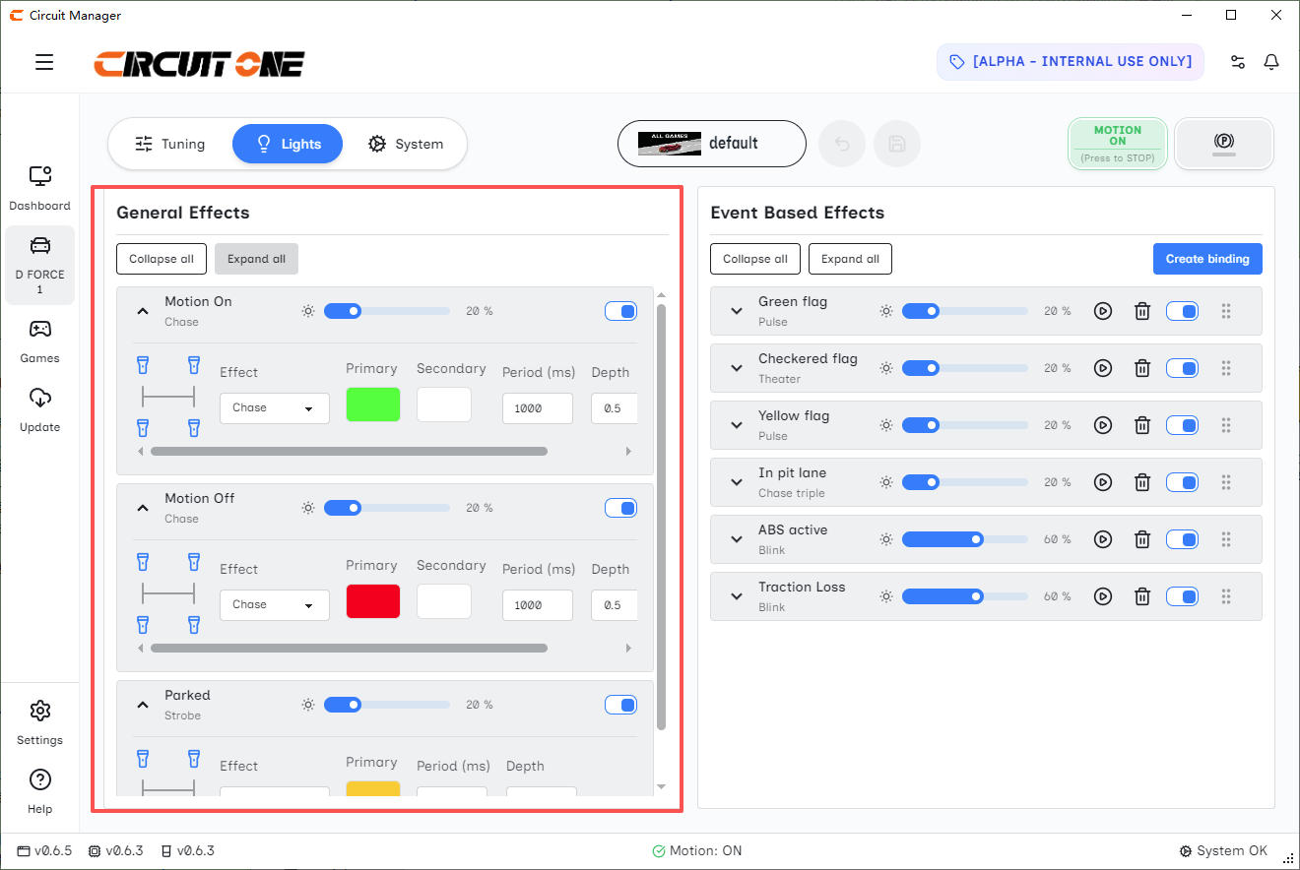

Step 9: Enable / Disable Lighting Effects per Axis
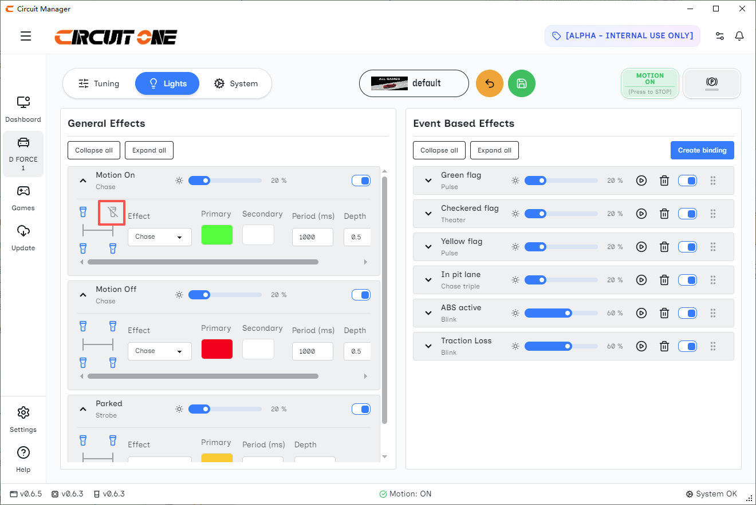

Step 10: Telemetry Data Lighting Effects Settings
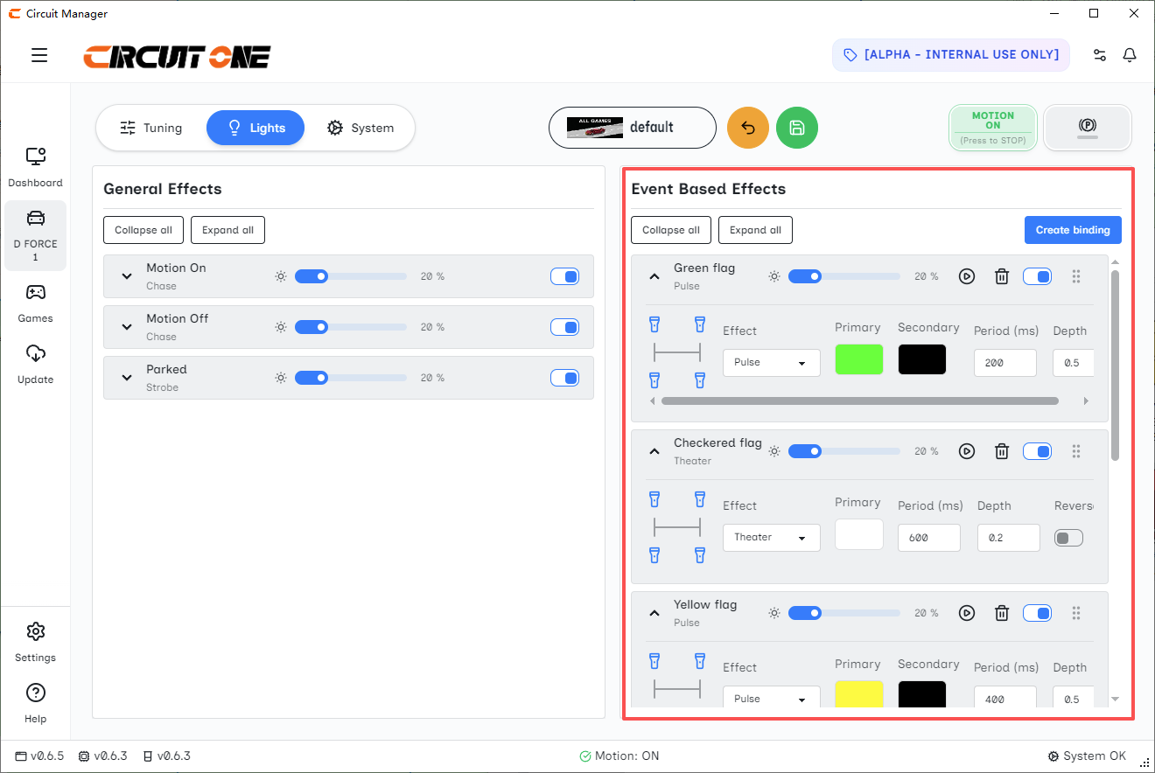

Step 11: Add New Telemetry Data Lighting Effects
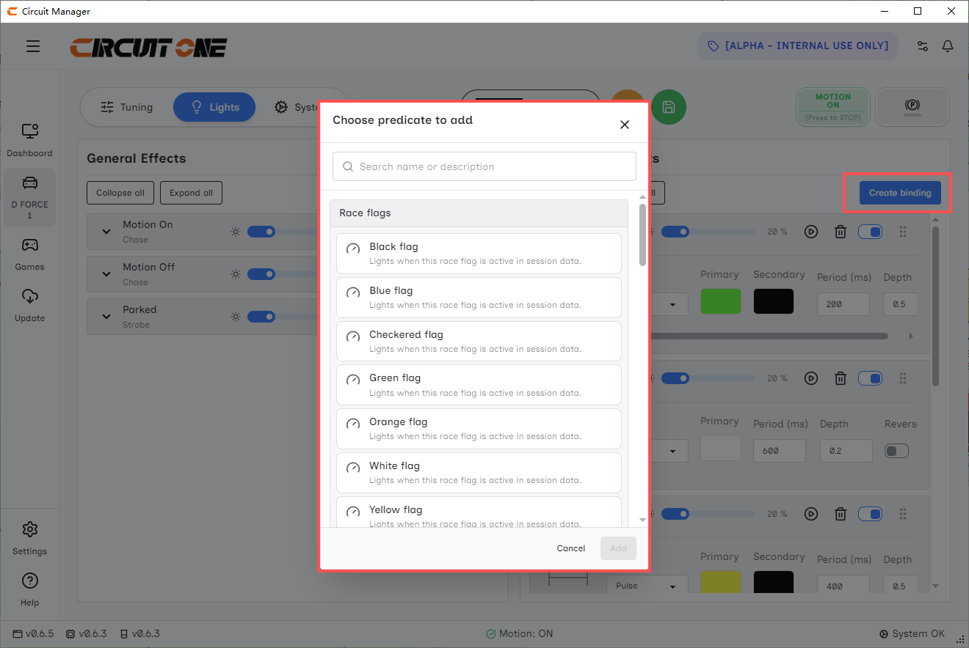

Step 12: Left-Click and Drag to Reorder
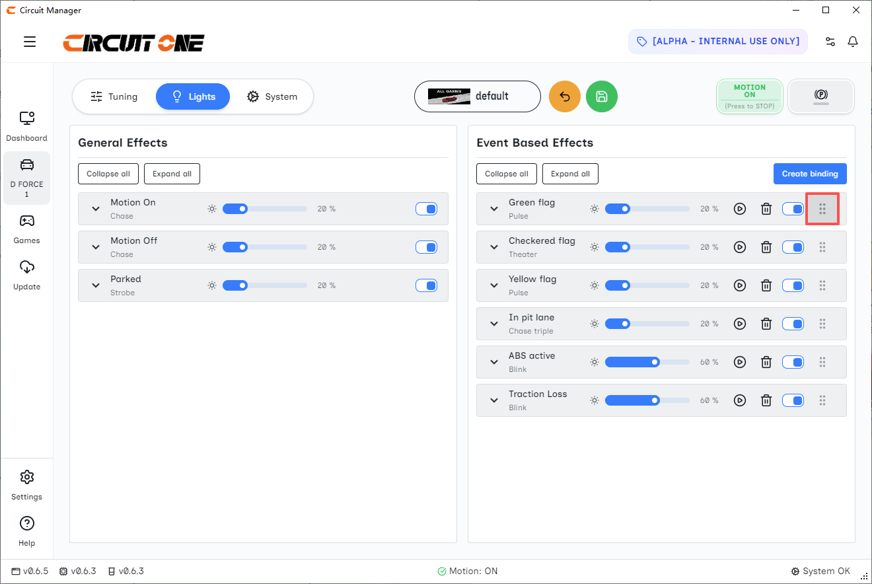

4. Important Notices

4.1 Safety Information

**Normal Operating Conditions:**
- Temperature: 0–40°C
- Voltage: 110V–220V

Exceeding these conditions may affect performance or cause malfunction. If the product has been exposed to extreme temperatures, allow it to return to normal room temperature before use.

- This product is intended **only** for simulated driving activities.
- Do not attempt to repair the device yourself. Unplug power and contact your dealer if issues persist.
- Keep away from rain or humid environments to prevent fire or electric shock.
- Use only the original power supply and accessories provided.
- Use standard wall outlets only.
- Turn off and unplug during thunderstorms or long periods of non-use.
- Do not disassemble the device (this will void the warranty).
- **Prohibited for children under 6 years old.**

**Additional Simulator Usage Warnings:**
- Children under 15 must be supervised by an adult. Use child mode for force feedback settings.
- First-time users should be guided by a professional.
- Keep the area clear of loose items (hair, clothing, cables) that could get caught.
- Users with epilepsy should consult a doctor before use. Stop immediately if any abnormal symptoms appear.
- Stop use and consult a doctor if you feel pain, numbness, or discomfort in hands, arms, shoulders, neck, or body.
- Not recommended for users with tendon or physical injuries.
- Be careful of moving parts, pinch points, and sharp edges.
- Limit sessions to **20–40 minutes** to avoid health risks.
- Wait at least **1 hour** after using the simulator before driving a real vehicle.
- Stop use immediately if the device behaves abnormally.

4.2 Warranty Information

**Warranty Period:**24 months from the date of purchase.

During this period, if quality issues arise under normal use, the company will provide free repair or replacement of defective parts.

**The following are NOT covered by warranty:**
- No valid proof of purchase or suspected forged documents
- Warranty claim in a different country/customs region from original purchase
- Unauthorized disassembly or modification
- Purchase from non-official or unauthorized sellers
- Cosmetic damage (scratches, dents, etc.) unless caused by material defect
- Damage from improper use, self-modification, or use of non-standard components
- Normal wear and tear or aging
- Removed or altered serial numbers
- Product reported as stolen
- Damage from accidents, lightning, fire, liquid, corrosion, earthquake, etc.

5. Brand Information
**Official Website:** https://circuitone.com/
**Email:** info@circuitone.com

